Elizabeth McDougle’s intriguing letter to Arthur Phillip Esq.

On the 14th September 1796, Elizabeth McDougle (McDougall), a convict who arrived in the colony in July 1791, penned a letter to Arthur Phillip. There is no doubt whatsoever that the recipient was the Australian colony’s previous governor, for the letter is addressed to ‘Arthur Phillip Esq, Late Governor of His Majestys Territories New South Wales.’ This article explores Elizabeth McDougall’s letter and its significance in suggesting close links between her and Arthur Phillip. This article also examines the intricacies of Elizabeth’s life, reflecting on what it reveals about the lives of the colony’s convict and emancipist women during the earliest years of settlement.

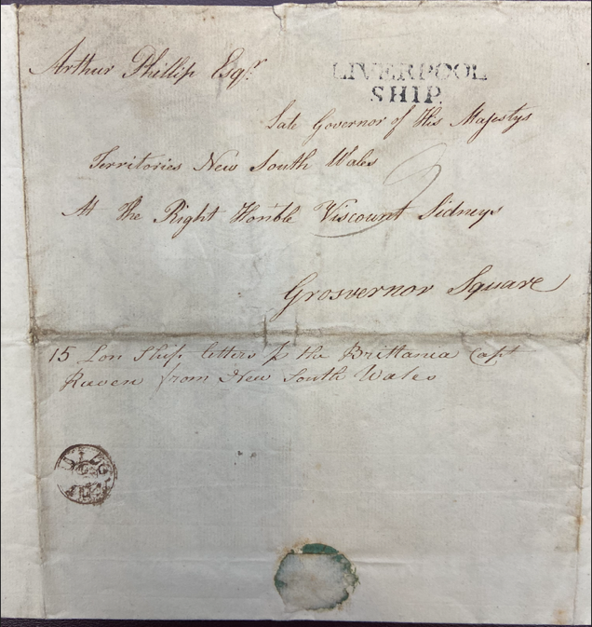
Image 1: The address of the letter written by Elizabeth McDougall to Arthur Phillip.
Elizabeth’s letter, whilst in many ways formal, nevertheless contains unmistakable evidence of an unusually close relationship with the colony’s late governor. She addresses him as ‘Most ever Hon^{d} Sir,’ a salutation which precedes her extending her ‘most Dutiful Thanks for your Honors Humaine Goodness to me.’ She informs Phillip that she has ‘received Five Pounds Sterling from Captain Waterhouse which has rendered Me and my Family an Infinite Service.’ This indicates that Phillip has sent five pounds to Elizabeth via Captain Henry Waterhouse, an associate of Phillip who accompanied him to the colony as midshipman aboard the vessel Sirius in 1788 and worked closely with the governor until his departure from the colony in 1791. Waterhouse, who would therefore have been regarded by Phillip as a close confident, returned to the colony as commander of the Reliance in September 1795, bringing the five pounds to Elizabeth at that time.

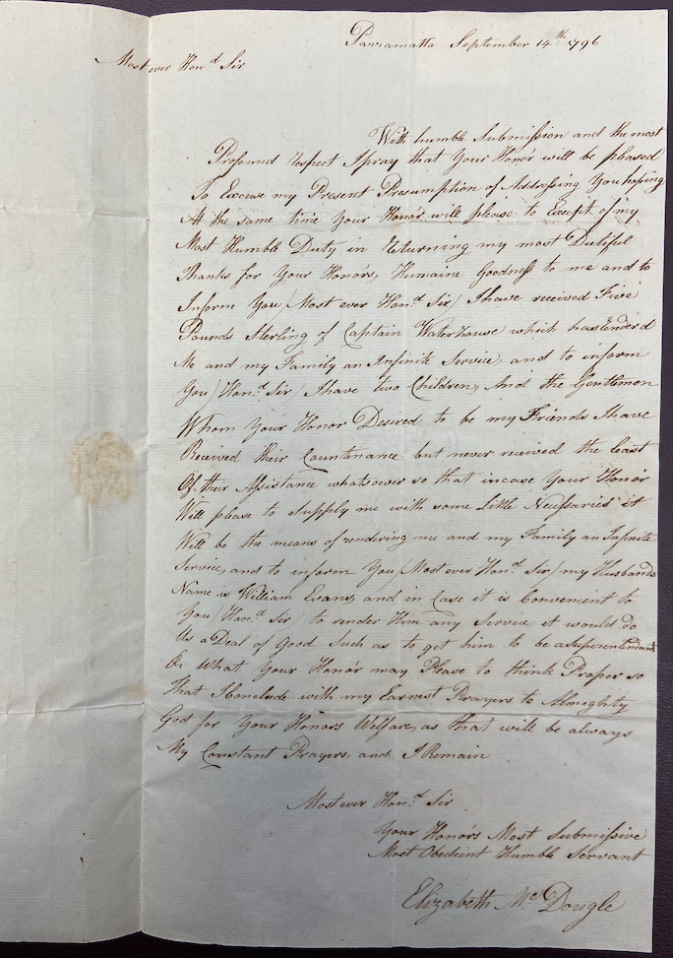
Image 2: Elizabeth McDougle's letter to Arthur Phillip, 1796.
Elizabeth informs Phillip that she has two children, then adds that ‘the Gentlemen Whom Your Honor Desired to be my friends have Received their Countenance but never received the least of their Assistance whatsoever.’ This indicates that, whilst the friends that Phillip selected for Elizabeth have provided her with moral support, they have not provided more practical means of assistance. Elizabeth then appeals to Phillip to ‘please to supply me with some Little Necessaries’ which ‘Will be the means of rendering me and my Family an Infinite Service.’ This is definitely no ordinary letter between a convict woman and a man of authority. Phillip is providing assistance to Elizabeth, not only financially but through orchestrating the support of friends of his choosing. Further, Elizabeth is not afraid to ask Phillip for favours, in a manner very different from the formal appeals for request, relief, redress or resistance to perceived injustices through the writing of a memorial or petition. Specifically, Elizabeth provides Phillip with the name of her husband, William Evans ‘and in Case it is Convenient Hond^{d} Sir to render Him any service it would do Us a Deal of Good Such as to get him to be a Superintendent Or what your Honor may Please to think Proper.’

Elizabeth ends her letter in the same way she commenced, formally with a hint of something more, stating ‘I Conclude with my Earnest Prayers to Almighty God for your Honors Welfare, as that will be always My Constant Prayers and I Remain Most Ever Hon^{d} Sir Your Honors Most Submissive Most Obedient Humble Servant.’ It is the degree of submission which is of interest here. It is not unusual for colonists to refer to a man in authority as ‘honoured sir,’ but to Elizabeth he is a ‘Most ever Hon^{d} Sir’ and she a ‘Most Submissive’ and ‘Most Obedient Servant.’ Colonists also often prayed for their governor’s welfare, but for Elizabeth, those prayers are ‘constant.’ The letter was sent via the vessel ‘Brittania [stet], Cap^{t} Raven’ which departed the colony in late 1796, arriving in England in June 1797. It was addressed to Phillip at ‘The Right Hon’ble Viscount Sidneys [sic] Grosvenor Square.’ Phillip had departed the colony on 11 December 1792, eighteen months after Elizabeth McDougall’s arrival in the colony. His health was failing and, after five demanding years he required medical attention to ease his ‘constant suffering.’ His intention was to return to the colony, but medical advice forced his formal resignation in July 1793. By 1796, his health recovered significantly for him to resume active naval duty.

Michael Flynn’s articles The Women in Arthur Phillip’s Life and A Diminutive Enigma, explore in some detail Arthur Phillip’s relationships with his two wives and suggest one possible colonial liaison. Neither article makes any mention of Elizabeth McDougall, although interestingly, Flynn does make reference to her letter in his biography on Elizabeth’s husband, William Evans. Phillip married his first wife, Margaret Charlott Tibbott, in London on 19 July 1763. At the time, Phillip was aged twenty-four and Margaret Charlott, a widow, was forty-two. In 1769, after six years, legal deeds of separation effectively ended the relationship, although the couple remained legally married until Margaret Charlott’s death in August 1792. On May 8th 1794, Phillip, a fifty-five year old widower residing back in England, married forty-three-year-old Isabelle Whitehead at St Marylebone Church of England, Westminster. According to Flynn, this marriage appears to have been one characterised by ‘a degree of marital bickering,’ but also of ‘deep affection on Phillip’s part.’ In retirement, the couple resided in Bath until Arthur’s death on 31 August 1814, three months after receiving a promotion to Admiral of the Blue.

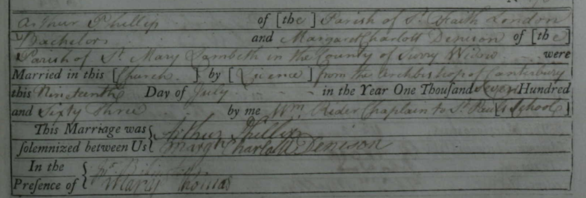
Image 3: The marriage of Arthur Phillip to Margaret Denison nee Tibbott, 1763.
It is Deborah Brooks who is suspected of being Arthur Phillip’s colonial companion. She arrived as a free woman aboard the First Fleet vessel Sirius, the partner of boatswain Thomas Brooks who had previously served with Phillip on a voyage to India. The diary of Edward Spain, who served with both Phillip and Brooks on the Indian voyage, suggests that Brooks was appointed to that voyage by Phillip because of his ‘partiality for the woman Deborah Brooks.’ Throughout his diary, Spain’s disaffection with both Phillip and Thomas Brooks is apparent, but he also reveals a degree of contempt for Deborah. He describes how four women were brought aboard the vessel Europe in 1782 including Deborah, who Phillip had ‘a sneaking kindness for.’ Babette Smith infers that, in order to collect the four women passengers, Phillip ‘diverted from his expected course, to the puzzlement of London officials and some grumbles among the crew.’ Whilst I can find no reference to this in Spain’s reminiscences, he does add that no one should ‘imagine that it was out of any partiality to any of them [the women] except one.’ He adds that ‘The Woman that Brooks brought with him had eloped from her husband…she it was that our noble commander had a partiality for and through her for the man [Thomas Brooks].’ She was, according to Spain, a ‘fancy woman’ and ‘concubine’ who had ‘free ingress and egress in and out of the great Cabbin.’

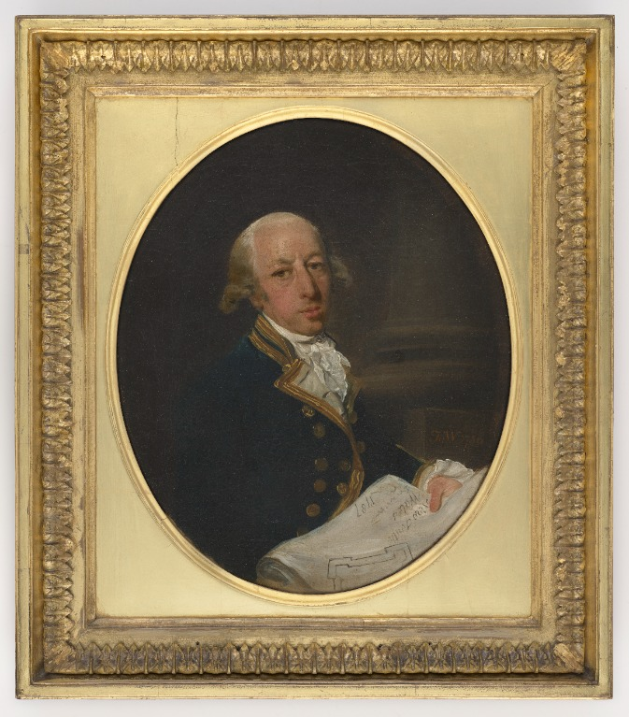
Image 4: Captain Arthur Phillip, 1786.
The insinuation here is that Deborah Brooks and Phillip formed a relationship aboard the Europe. This, when linked to the fact that both Thomas Brooks and Deborah sailed with Phillip aboard the First Fleet, seems to imply that the relationship may have continued. However, Spain’s references to Deborah as a ‘fancy woman’ and ‘concubine’ are made in the context of her being Thomas Brooks’ mistress, rather than Phillip’s, although Phillip’s ‘partiality’ to Deborah is also clearly implied. A letter believed to have been penned by Deborah was published in the Hampshire Chronicle on 29 June 1789. In it, she stated that her husband was absent from the colony and ‘I am rather dull without him.’ She describes Phillip as ‘our worthy Governor,’ stating that she lives ‘near the Governor, and within call of his centinels, so that I am perfectly safe from thieves. The only correspondence I have here is the chaplain’s wife [wife of Rev Richard Johnson], who I find to be an exceedingly agreeable lady, and who resides near me.’ It was not unusual that Deborah should reside near the governor, as the settlement was small and confined, and a free woman living alone would do so in the same area as other free settlers. It is strange that Deborah makes no mention in her letter of social events at Government House or of ‘correspondence’ with the Governor if, indeed, she did spend time socially there. In March 1791, Thomas and Deborah Brooks departed the colony aboard the vessel Waaksamheid, marrying in 1792 and, according to Flynn, ‘lived happily until his death while on active naval service in 1802.’

Flynn questions the allegations that Deborah was ‘some kind of mistress to Phillip,’ which he believes remains unproven. He adds that ‘as a boatswain’s wife she may have performed some household management functions for Phillip and she may have continued in this role in the colony, though living in her own household and not in Government House.’ William Coleman, in his review of Babette Smith’s book Defiant Voices, writes that ‘the evidence for [the contention that Arthur Phillip had a mistress in Deborah Brooks] is thin to the very verge of non-existence,’ and is plainly an attempt to ‘drag him down…as a male exploiter of females.’ He notes that Deborah was a free woman who ‘wasted little time in returning to England,’ seemingly dismissing the matter of Arthur and Deborah having any relationship other than a friendship.

It is within this context of our current understanding of Arthur Phillip’s personal relationships, that we return to the significance of Elizabeth McDougall’s letter to Arthur Phillip in 1796. Deborah Brooks departed the colony with her husband in March 1791 and Elizabeth McDougall arrived aboard the vessel Mary Ann on July 9 1791. Born circa 1771, Elizabeth had been convicted at the Old Bailey on 9 December 1789 of the theft of clothing to the value of £55.10s, and sentenced to transportation for seven years. When she arrived in the colony, it was still an infant settlement, having been founded only three-and-a-half years earlier. My previous research indicates that Elizabeth would have found her own accommodation soon after arrival, either constructing her own primitive hut on land settled by naked possession (squatting), or sharing accommodation with others. Very few women were assigned to live-in with their employers, but rather undertook their designated work, then returned to their own accommodation. There is no record of Elizabeth’s employment upon arrival, but it is possible that she undertook some domestic duties for the Governor. Speculative though that supposition is, Elizabeth’s letter indicates that, without any doubt, she established a relationship with the governor that exceeded the accepted governor/ convict dealings. Given that Phillip departed the colony in December 1792, Elizabeth and Phillip can only have known each other in the colony for eighteen months. During that short time, they established a friendship sufficient for Elizabeth to have expectations that Phillip would provide support not only financially, but by providing ‘some Little Necessaries’ and enhanced employment prospects for her partner, William Evans. It is worth noting that Phillip appears to have acceded willingly to those expectations by sending her money.

By the closing months of 1792, Elizabeth was expecting her first child, a son Hugh born, according to his baptism record, to William Evans and Elizabeth McDougall in August 1793. His baptism indicates that his parents were unmarried, as Elizabeth uses her maiden name. By 1795, at the baptism of the couple’s second child George, Elizabeth uses the surname Evans. There is, however, no record of a marriage between the couple. The entry in the 1822 Muster for Elizabeth lists her under her maiden name McDougall, having arrived on the vessel Mary Ann, free by servitude, mother of Evans. The entry for her children, Thomas aged 11, and Elizabeth aged 8, list them as the children of Elizabeth McDougal, although it must be noted that convict did usually appear under their name of conviction in the official musters.

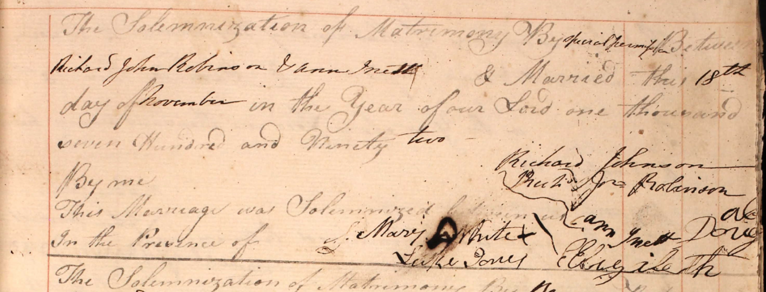
Image 5: The marriage of Ann Inett to Richard John Robinson, November 1792.
On 18 November 1792, Elizabeth acted as witness to the marriage of Ann Inett and Richard John Robinson at St, John’s Church, Parramatta. She signed the register Elizabeth Dougal, an accepted contraction of her surname. Ann Inett, a First Fleet convict, had been the housekeeper and partner of Deputy-Governor Philip Gidley King on Norfolk Island between 1788 and 1790, the couple having two sons. We may speculate that Elizabeth, in serving as a witness at Ann’s marriage, was her friend. It also emerges that Ann and Elizabeth were neighbours, and possibly were so even as early as 1792. We may further speculate that the bond between Ann and Elizabeth may have been enhanced by the fact that both were convict women who had established relationships with colonial men of authority, Ann with Philip Gidely King, and Elizabeth with Arthur Phillip. Whilst acknowledging that we remain unaware of the extent of Elizabeth’s relationship with Phillip, her letter proves that she did have a relationship of some kind, be it familial, friendship or something more, and this in itself would have served as a link between Ann and Elizabeth.

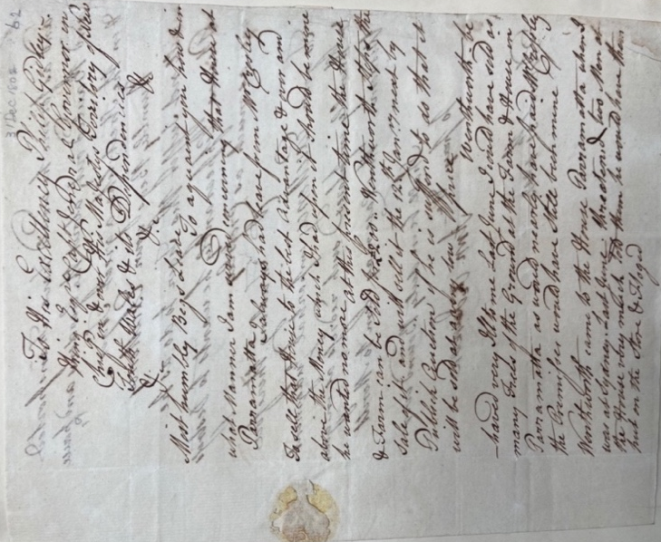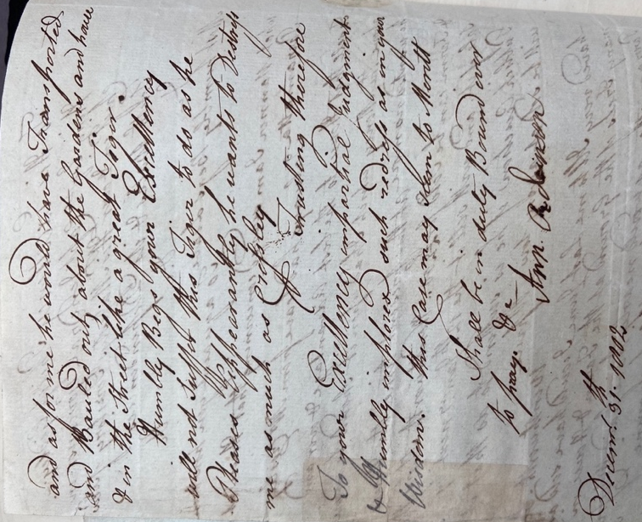
Image 6: Ann Robinson's memorial to Governor King, 31 December 1802.
My research into formal letters (memorials) written to those in authority during the period 1788 to 1811, revealed a memorial written by Ann Inett to her former partner, Philip Gidley King, in December 1802. This was some twelve years after their relationship ended in March 1790, after King returned to England on official business. Whilst in England, King married before once again returning to Norfolk Island with his new wife. Despite King’s marriage, and Ann’s 1792 marriage to Robinson, it is apparent from her memorial that Ann remained under King’s patronage and friendship during his time in the colony. In her letter, Ann pleads with King to assist her in a land dispute with John Macarthur. Her letter is of great interest given its duality, serving as both a personal entreaty to her ex-partner and a constitutional appeal to the governor. Like the letter Elizabeth wrote to Phillip, Ann uses the formal and respectful conventions required when writing to a man of authority. Both use the word ‘humble’ on several occasions and both refer to the men as ‘Your Honor’ [sic] or ‘your Excellency,’ and never by name. Given we know that Ann was in an intimate relationship with King and was mother to his two children, her memorial establishes the accepted, formal etiquette of correspondence with a man of authority, regardless of past intimacy. In light of this, the formality of Elizabeth’s memorial to Phillip is not a barrier to them having formed a close relationship.

William Coleman, in his review of Babette Smith’s book Defiant Voices notes that ‘in this terrain of sexual contact between free men and convict women, a victimhood historiography of female convicts is ever ready to assert itself.’ Coleman adds that Smith’s book indicates that ‘in the annals of the felony of New Holland there are, in fact, few indications of sexual coercion of, or violence against its female portion.’ To convict women, states Coleman, ‘men were a means of working the system.’ He highlights Babette Smith’s assertion that ‘an astonishing number of long-lasting relationships’ developed between ‘women prisoners and gentlemen who arrived in the first two decades of European settlement.’ Those relationships, emphasised Smith, ‘were domestic relationships, not licentious ones.’

Elizabeth’s letter sheds interesting perspective on this statement. It indicates that her relationship with Phillip, whilst short-term, was nevertheless of benefit to her, a means perhaps of ‘working the system’ in order to enhance convict life within the colony. Elizabeth’s relationship with Phillip undoubtedly served to ‘underpin’ her more ‘comfortable circumstances.’ She specifically indicates this to Phillip, writing that the money he sent ‘has rendered Me and my Family an Infinite Service.’ However, she requires more, appealing to Phillip to ‘please to supply me with some Little Necessaries’ and consider assisting her husband into a more prestigious position, such as that of superintendent. Her expectation is for Phillip to continue to provide for her in a number of ways, an expectation that one associates with close personal ties. Certainly, Elizabeth would not have continued her correspondence some four years after Phillip’s departure, had her association with Phillip been licentious or of no significance to her.

Elizabeth’s partnering with William Evans could also be interpreted to mirror the circumstances of other convict women who were encouraged to marry by the gentleman who could not himself become their husband. Molly Gillen in her biography on Ann Inett, stated of Ann’s 1792 marriage to Richard John Robinson that ‘it has been suggested that King arranged a good marriage for her.’ Perhaps King also facilitated the 30-acre land grant that Ann received in her own name some two years later. Another convict woman, Ann Green, spent ‘some years as the partner of assistant surgeon Dennis Considen in Sydney and Norfolk Island.’ Jan Barkley-Jack states that ‘Ann’s befriending by [Considen] gave her a partner who accorded Ann greater respect and public favour.’ She speculates that it was Considen who may have orchestrated her marriage to William Blady, ‘or perhaps it was Ann herself in reaction to Considen’s permanent departure.’ Phillip departed the colony in December 1792, and it appears that Elizabeth formed a partnership with William Evans at about this time. The same speculation demonstrated by Gillen and Barkley-Jack leads one to question if Phillip also encouraged Elizabeth to form a partnership, given both his impending departure and his acknowledged tendency to choose friends for Elizabeth. Or perhaps Elizabeth decided to form her own relationship with Evans, demonstrating agency given Phillip’s impending departure.
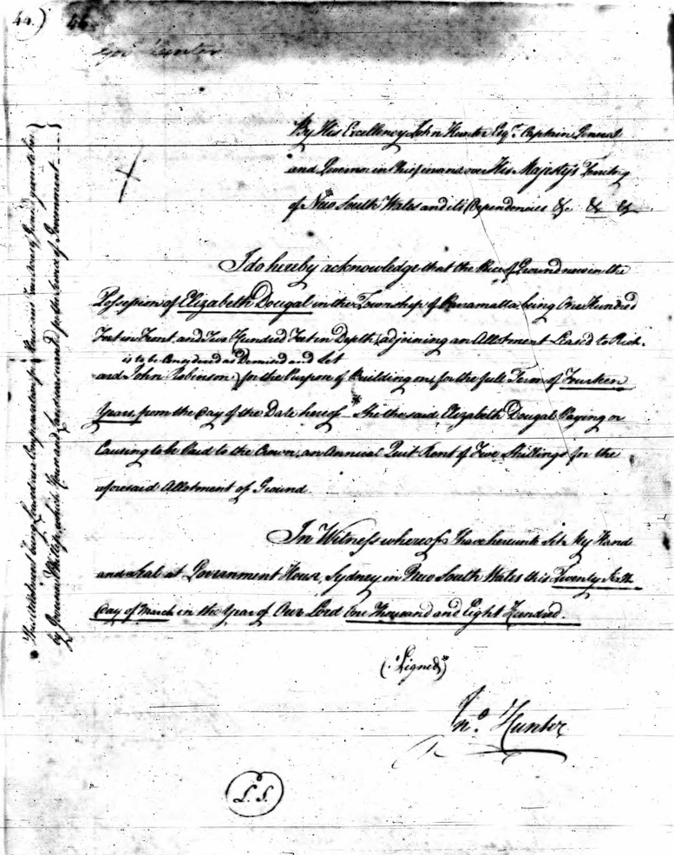
Image 7: The formal lease for a town block in Parramatta in the name of Elizabeth Dougal.
Arthur Phillip’s main residence was in Sydney, so Elizabeth’s friendship with Phillip could indicate that she resided in Sydney before moving to Parramatta. However, Phillip also spent time in Parramatta as part of his duties. We know that Parramatta became Elizabeth’s home by the time Phillip left the colony in December 1792. It was in Parramatta that she witnessed Ann Inett’s marriage in November 1792, and it was there that her first son was baptised in September 1793. Elizabeth’s partner, William Evans, received a grant of thirty-acres of land at The Ponds, an area near Parramatta, in April 1794. Of some interest is the fact that the grant appears to have originally been made out to Hugh Evans, Elizabeth’s eldest child. The image below reveals Hugh’s name crossed out and replaced by William’s. It is tempting to believe the grant may have originally been made to Hugh to secure his welfare, or perhaps it was simply an administrative error. Elizabeth’s 1796 letter to Phillip was penned in Parramatta and, four years later, in March 1800, Elizabeth obtained a lease for land in Parramatta township under her maiden name Elizabeth Dougal. This serves as further proof that she and William had not legally married. We know that Elizabeth resided on this land prior to the lease being formalised, given that her official lease stated that ‘the piece of Ground’ is ‘now [already] in the Possession of Elizabeth Dougal.’ During these early years, leases often legitimised land already occupied by naked possession. Archaeological evidence suggests that the buildings on her land were originally convict housing erected in 1790, with improvements and extensions made by emancipists or free persons living in the repurposed convict huts before 1800. Of interest is the fact that Elizabeth’s land was located next to that of Ann (nee Inett) and John Robinson, who operated the Yorkshire Grey Hotel, one of the earliest Inns in that area, from their property. This indicates that Elizabeth may have resided on this land as early as 1792, forming the close association with Ann Inett and her husband that led to her acting as a witness at their marriage.

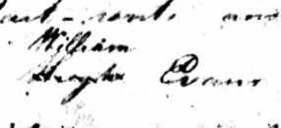
Image 8: The grant of William Evans, showing that the original name recorded was that of Hugh Evans, Elizabeth's eldest child, crossed and replaced by William Evans.
Elizabeth was representative of many of the convict and emancipist women who lived in the colony during its earliest years of settlement. It was not unusual for women to remain unmarried, despite being in significant and long-term relationships. Marsden’s Female Muster of 1806 confirmed the colonial preference for co-habitation, with seventy-one percent of women identified as concubines. It is hardly surprising that many women chose co-habitation rather than marriage. Those in de facto relationships were classified as feme sole (single women), retaining their full legal rights and capabilities. In comparison, married women were often unable to own land in their own name, due to the rules of couverture. Coverture meant that husband and wife were regarded as one entity in the eyes of the law, namely that of the husband. After marriage, women became feme covert, essentially ‘hidden women,’ forfeiting their own surname and legal rights and having no control over their money or property. Elizabeth’s de facto status enabled her not only to own land in her own name, but mortgage that land. She did so on two occasions, firstly on 30 October 1802, using the property as surety for a loan of £24, and again on 27 November 1802, to secure a former encumbrance of £26.

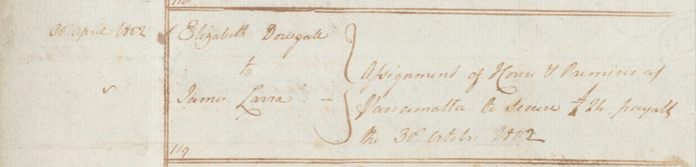

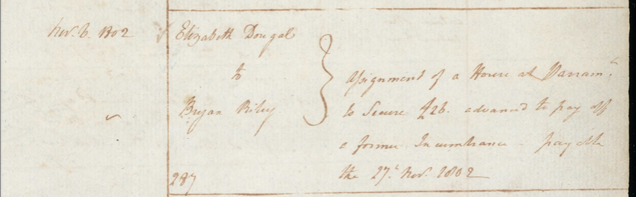
Image 9: Assignment of the Parramatta property of Elizabeth Dougall to secure debts, 1802.
Like so many women in the colony, Elizabeth suffered the heartbreak of having a number of her children pre-decease her. Her eldest son Hugh, a seaman born in 1793, died aged twenty in 1813, the victim of a massacre on the Fiji Islands. Her second son, George, was killed by snakebite in 1798 aged just three years. Elizabeth’s third child Sarah, was killed in July 1818, after her clothes caught alight whilst dressing a small child by the fire. She was just fourteen years old. At least two children survived to adulthood, namely Thomas born in 1813, and Elizabeth born in 1817. Elizabeth’s challenges were not, however, confined to the loss of children. In November 1822, Elizabeth wrote a memorial (formal letter) to the Governor’s secretary, requesting that that her husband, William, be admitted to an asylum given his ‘privation of reason’ and ‘deranged condition.’ She stated that his condition rendered him ‘unable to provide for the support of his family and that memorialist has no means to provide for herself and children but from her own personal labour.’ Further, the benefits of her labour ‘is in a great measure deprived and prevented by the sensless [sic] conduct of her said husband…which has reduced me to a most necessitious state.’ William was placed first in Carter’s Barracks and then sent to the Castle Hill Lunatic Asylum. One can only imagine the impact of William’s illness on Elizabeth and the family, and the distress this caused. By 1828 William, aged 60, was discharged from the asylum and working in Kent Street, Sydney as a servant to merchant Thomas Raines. Elizabeth was a servant to a sawyer and his wife on their farm at Botany. There is no record of William’s death, however Elizabeth died at Maitland in August 1867, aged ninety-six years. Her death notice stated that she was ‘one of the oldest colonists in New South Wales’, given that she had been seventy-seven years in the colony.

Elizabeth McDougall’s letter to Arthur Phillip leaves very little doubt that the couple had an association of some kind, be it familial, one of friendship or something more intimate. The letter, in thanking Phillip for his ‘Humane Goodness’ in sending her financial support yet asking for more in the form of ‘some Little Necessaries’ as well as improved employment options for her husband, is of even greater significance given that it was penned almost four years after Phillip’s departure from the colony. The fact that Phillip supported Elizabeth financially and through selecting friends to offer moral support, indicates that their relationship was very different to that expected between a governor and convict. It must be noted that there appeared to be no comment within the colony on Phillip having a romantic relationship, either with Deborah Brooks or Elizabeth McDougall. Phillip appears to have been a man of some integrity, and his dedication to the colony was apparent, yet there would have been detractors who would gladly have spread rumours had there been foundation to do so. However, it remains the job of historians to analyse the clues contained within primary sources, and Elizabeth’s letter demonstrates that she remained under the patronage and friendship of Arthur Phillip for a number of years after his departure from the colony. This patronage provided ‘an Infinite Service’ to both Elizabeth and her family, a legacy of her ties to the colony’s late governor.

Elizabeth McDougle, "Autograph Letter Signed by Elizabeth Mcdougle, Written from Paramatta, to Arthur Phillip," (State Library of New South Wales, 1796). DLDOC 63.
Ibid.
Ibid.
Vivienne Parsons, "Waterhouse, Henry (1770–1812)," in Australian Dictionary of Biography, National Centre of Biography (Australian National University, 1967).
McDougle, "Autograph Letter Signed by Elizabeth Mcdougle, Written from Paramatta, to Arthur Phillip."
Narissa Phelps, "Your Memorialist Humbly Prays: Australian Colonists’ Entreaties to Colonial Administrations, 1788–1810" (Griffith University, Queensland, Australia, 2024 (submitted)).
Vivienne Parsons, "Raven, William (1756–1814)," in Australian Dictionary of Biography, National Centre of Biography (Australian National University, 1967).
B.H. Fletcher, "Arthur Phillip (1738–1814)," in Australian Dictionary of Biography (Canberra, ACT: National Centre of Biography, Australian National University, 1967).
Ibid.
Ibid.
Ibid.
Michael Flynn, "The Women in Arthur Phillip's Life," Journal of the Royal Australian Historical Society 105, no. 1 (2019). "A Diminutive Enigma: New Perspectives on Arthur Phillip, First Governor of New South Wales," Sydney Journal 5, no. 1 (2016).
The Second Fleet: Britain’s Grim Convict Armada of 1790 (Sydney: Library of Australian History, 1993), 265–66.
" Marriage of Arthur Phillip to Margaret Charlott Denison, 19 July 1763," in London Church of England Parish Registers, London Metropolitan Archives; London, England, P69/AND2/A/01/Ms 6672/2.
Flynn, "A Diminutive Enigma: New Perspectives on Arthur Phillip, First Governor of New South Wales," 4, 9, 15. Flynn believes Margaret Charlott to have been a 'shrewd, practical and cautious individual.' She executed a pre-nuptual agreement one day prior to her marriage to Arthur, protecting her financial interests against her husband's control. Her independent means prior to marriage 'allowed her to transcend provincial origins and setbacks to join the wealthy and successful trade elite of London', and to enjoy her role as Lady of her home, Dorset Manor. She remained an independent woman and 'fiercely loyal and generous to her family and friends.'
Ibid., 4–5.
"Marriage of Arthur Phillip Esq. To Isabella Whitehead, 8 May 1794," in London Metropolitan Archives; London, England, UK; London Church of England Parish Registers; Reference Number: P89/MRY1/176.
Flynn, "A Diminutive Enigma: New Perspectives on Arthur Phillip, First Governor of New South Wales," 6.
Fletcher, "Arthur Phillip (1738–1814)."
" Marriage of Arthur Phillip to Margaret Charlott Denison, 19 July 1763."
Flynn, "The Women in Arthur Phillip's Life."
Mollie Gillen, The Founders of Australia (Sydney, NSW: Library of Australian History, 1989), 50.
Ibid.
Edward Spain, "Edward Spain, Reminiscences," in Mitchell Library, State Library of New South Wales, SAFE/C 266. Image 57 (of 157).
Babette Smith, Defiant Voices. How Australia’s Female Convicts Challenged Authority (Canberra, ACT: NLA Publishing, 2021), 77.
Spain, "Edward Spain, Reminiscences." Image 57.
Ibid.
Ibid. Image 61, 65 and 58 (of 157).
Francis Wheatley, Captain Arthur Phillip, 1786. Mitchell Library, State Library of New South Wales, ML 124.
"Letter from ‘an Officer’s Wife, of One of His Majesty’s Ships at New South Wales, to Her Acquaintance at Gosport, Received Last Week.," Hampshire Chronicle, 29 June 1789.
Ibid.
Flynn, "The Women in Arthur Phillip's Life," 18.
William Coleman, "Overturning Myths – Australia’s Early Female Voice," The Sydney Institute, https://thesydneyinstitute.com.au/blog/overturning-myths-australias-early-female-voice/.
Ibid.
Phelps, "Your Memorialist Humbly Prays: Australian Colonists’ Entreaties to Colonial Administrations, 1788–1810." See Chapter 5, 'Women and the Land.'
The baptism of Hugh Evans, 15 September 1793. "Baptisms, 1790–1825; Marriages, 1789–1823; Burials, 1790–1825; Parish: St. John's Anglican Church Parramatta," (St. John's Parramatta, Marriages, 1790–1966 [database on-line]: Ancestry.com Operations, Inc.).
The baptism of George Evans, 27 October 1795. Ibid.
Family historian Alan Thomas states that the marriage occurred on 6 July 1793, and that he has ‘the original hand written Marriage Certificate’ in his possession. I contacted him for a copy but to date have had no reply. Had this been the case, I question why there is no official marriage entry in the registers and why Elizabeth did not use the surname Evans in the baptism record of her son Hugh.
Carol J. Baxter, General Muster and Land and Stock Muster of New South Wales 1822 (ABGR, 1988), 309, 157.
The marraige of Ann Inett to Richard John Robinson, 18 November 1792. "Baptisms, 1790–1825; Marriages, 1789–1823; Burials, 1790–1825; Parish: St. John's Anglican Church Parramatta."
Ibid.
Cheryl Timbury, "Ann Inett," First Fleet Fellowship Victoria Inc., https://firstfleetfellowship.org.au/convicts/ann-inett/.
Memorial of Ann Robinson to Philip Gidley King, 31 December 1802. King family correspondence, letters and memorials etc. received with drafts of letters sent, Vol. 1, 1799–1828, Mitchell Library, State Library of New South Wales, SAFE/A 1976, (SAFE 1/312, p. 62–65
Phelps, "Your Memorialist Humbly Prays: Australian Colonists’ Entreaties to Colonial Administrations, 1788–1810," Chapter 5.
Memorial of Ann Robinson to Philip Gidley King, 31 December 1802.
Timbury, "Ann Inett". Ann was described as ‘an attractive woman, small framed, dark haired and with a neat and clean appearance.'
Flynn, The Second Fleet: Britain’s Grim Convict Armada of 1790, 505. Valda Rigg, "Convict Life: A ‘Tolerable Degree of Comfort’," in Norfolk Island and Its First Settlement, 1788–1814, ed. Raymond Nobbs (North Sydney: Library of Australian History 1988), 107.
Phelps, "Your Memorialist Humbly Prays: Australian Colonists’ Entreaties to Colonial Administrations, 1788–1810," Chapter 5.
Coleman, "Overturning Myths – Australia’s Early Female Voice".
Ibid.
Smith, Defiant Voices. How Australia’s Female Convicts Challenged Authority, 76.
Ibid.
Ibid. Smith makes this comment in regard to another convict women, Margaret Catchpole, whose relationship with George Caley 'probably underpinned Margaret Catchpole's comfortable circumstances.'
McDougle, "Autograph Letter Signed by Elizabeth Mcdougle, Written from Paramatta, to Arthur Phillip."
Gillen, The Founders of Australia, 188.
Grant to Ann Robinson, 23 August 1794, SANSW Fiche 3267; 9/2731 fo.200.
Smith, Defiant Voices. How Australia’s Female Convicts Challenged Authority, 76.
Jan Barkley-Jack, Hawkesbury Settlement Revealed: A New Look at Australia's Third Mainland Settlement, 1793–1802 (Dural, NSW: Rosenberg Pub Pty Limited, 2009), 394.
Lease to Elizabeth Dougle, 26 March 1800, SANSW Fiche 3268; 9/2731 fo.22.
Grant of William Evans, 1 April 1794, SANSW Fiche 3267; 9/2731 fo.22.
Ibid.
Lease to Elizabeth Dougle, Ibid.
Ibid.
Phelps, "Your Memorialist Humbly Prays: Australian Colonists’ Entreaties to Colonial Administrations, 1788–1810," Chapter 5.
Edward Higginbotham, "The Excavation of Buildings in the Early Township of Parramatta, New South Wales, 1790–1820s," The Australian Journal of Historical Archaeology (1987): 13–15.
Grant of William Evans, 1 April 1794, SANSW Fiche 3267; 9/2731 fo.22.
Carol J. Baxter, Musters of New South Wales and Norfolk Island 1805–1806 (Netley, S.A.: Society of Australian Genealogists, 1989), 146–47. Kay Saunders and Raymond Evans, Gender Relations in Australia: Domination and Negotiation (Harcourt Brace Jovanovich, 1992), 118. Governor King himself reported in 1806 that a mere twenty-eight percent of adult women in NSW were married.
Catherine Bishop, "When Your Money Is Not Your Own: Coverture and Married Women in Business in Colonial New South Wales," Law and History Review 33, no. 1 (2015): 182.
Amy Louise Erickson, "Coverture and Capitalism," History Workshop Journal 59, no. 1 (2005): 4.
"Registers of Assignments and Other Legal Instruments," ed. Land and Property Management Authority and State Records Authority of New South Wales (Sydney: Land and Property Management Authority, 2008). 30 October 1802, Vol. 1 fo. 24/119; 27 November 1802, Vol 1 fo.63a/287.
Ibid.
"Sydney Gazette and New South Wales Advertiser." 23 October 1813, p. 2.
The family tree of Alan Thomas, Ancestry.com. Thomas cites the death as referenced in the Everingham family history.
Due to the fact that many of Elizabeth’s children were neither baptised nor had their births registered, there is some doubt as to the number of children that William and Elizabeth had. Her death certificates cites only Thomas and Elizabeth surviving but, unlike modern birth certificates, does not list deceased issue. It appears there may have been a son Charles Evans who inherited the original 30-acre grant at The Ponds in 1834, however there is no mention of him in any other records.
Memorial of Elizabeth Evans, 15 November 1822, SANSW, Reel 6055; 4/1762 fo.76.
Ibid.
Ibid.
Forwarding William Evans to the Castle Hill Asylum, 5 May 1823, SANSW, Reel 6010; 4/3508 fo.248–249.
Elizabeth A. Evans, New South Wales Register of Births, Deaths and Marriages, 5902/1867.
Death, The Maitland Mercury and Hunter River General Advertiser. 8 August 1867, p. 1.

